**Q1: Wap to demonstrate ternary operator .define a variable marks  .ask its value from user and using ternary operator check if marks > 40 store "Pass" in result varible else store "Fail"**

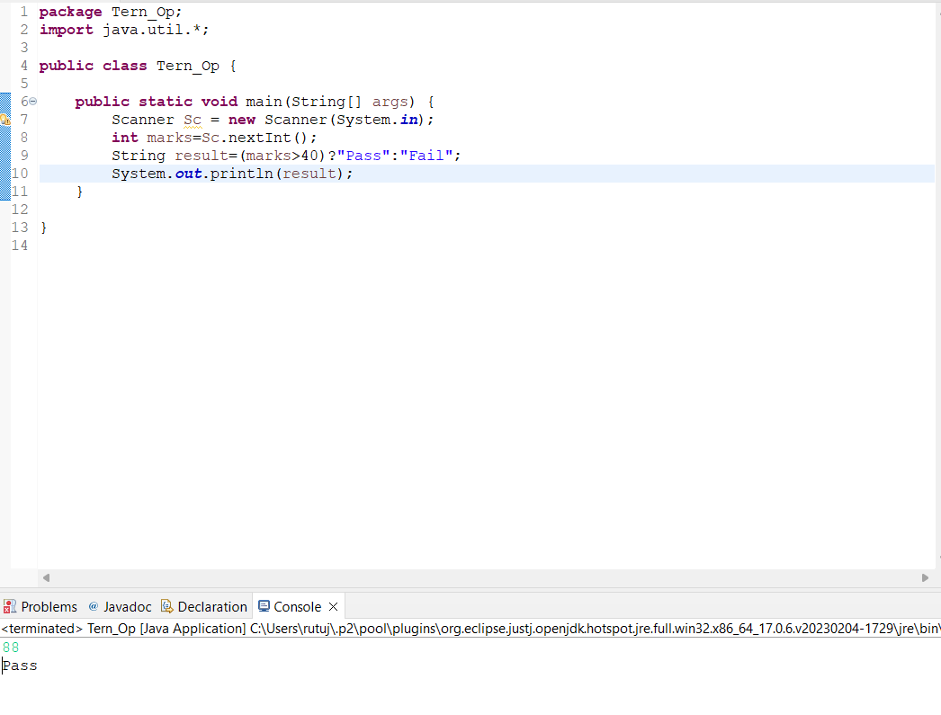

**Q2: Using ternary check if number entered by user is positive or negative .  
In case number is positive store "Positive number" else store negative number to Result variable**

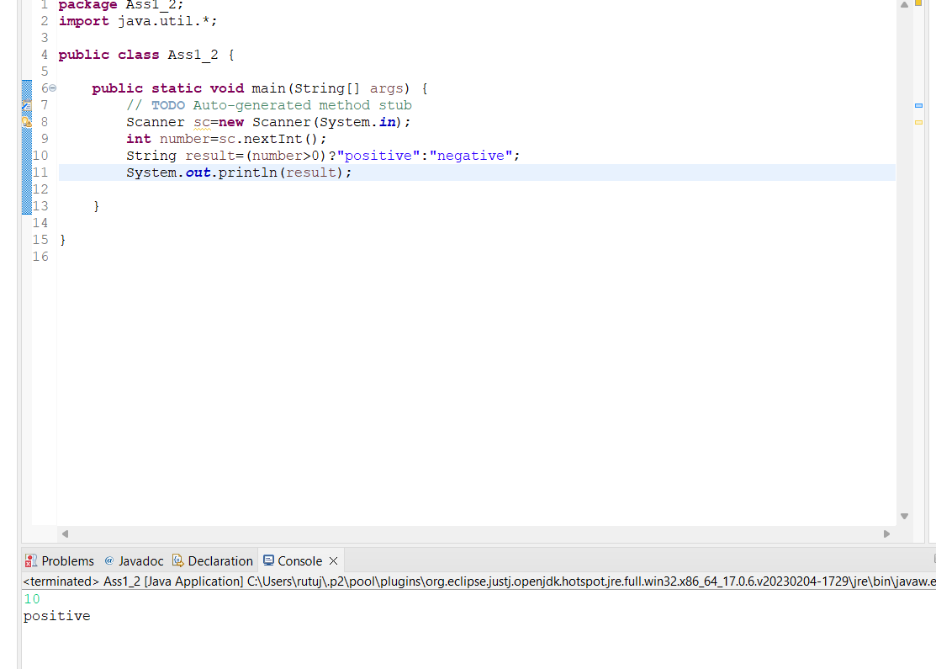

**Q3: WAP to ask name, age and salary of an employee and print on console.**

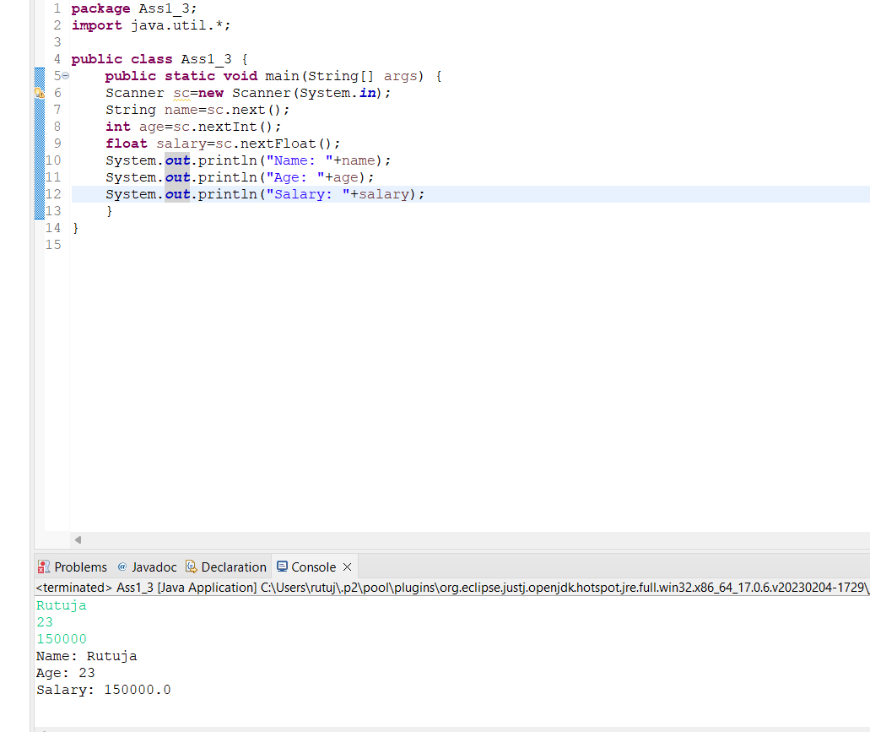

**Q4: Wap  that ask two numbers from user and print greater number among two**

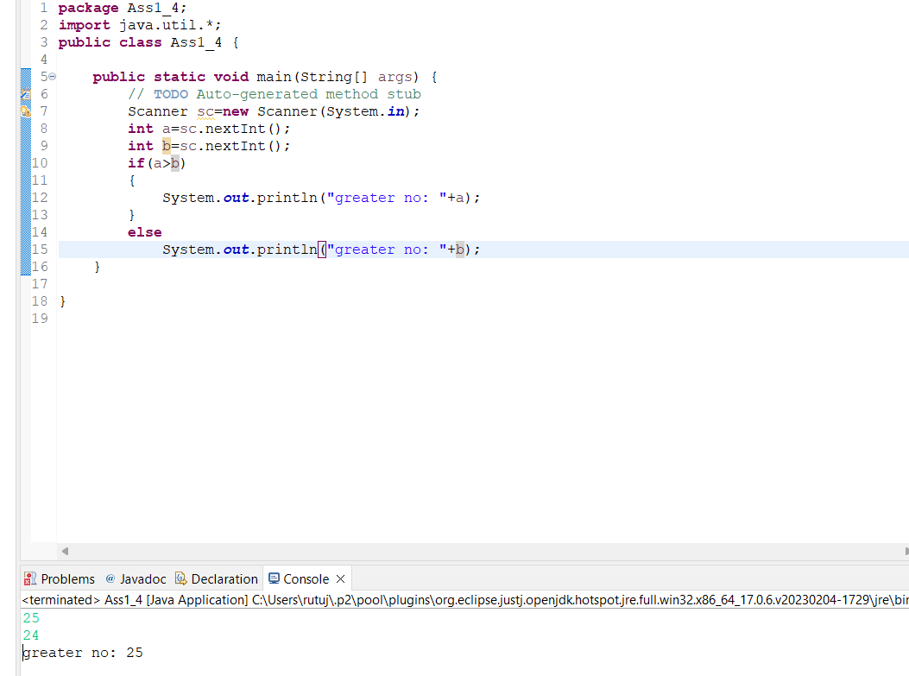

**Q5: Wap to ask product name and price of product from user and calculate discount i.e   
if price > 2000 then discount is 10 percent of price   
else   
discount is 7 % of price**

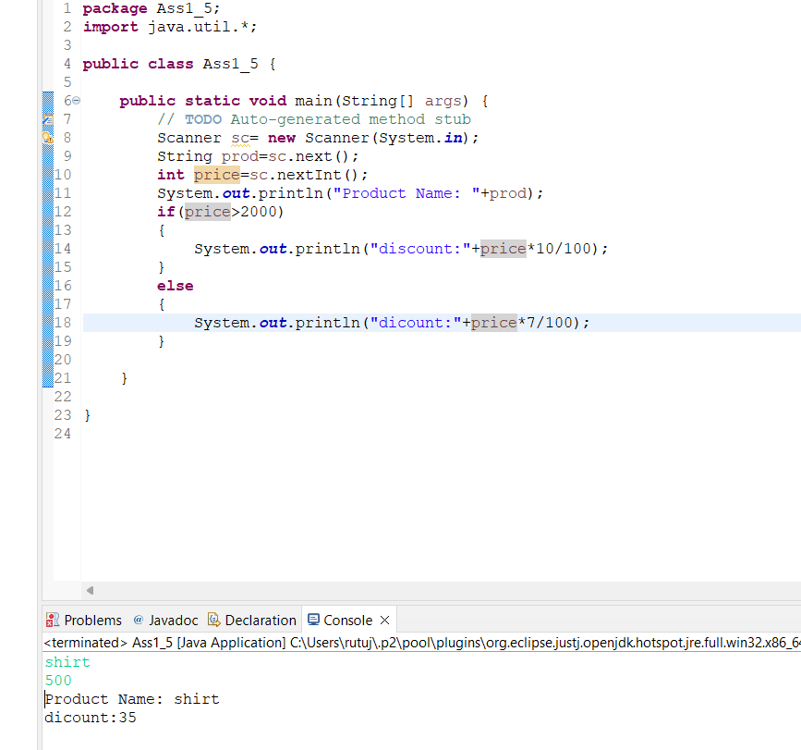

**Q6: Wap to swap two numbers**

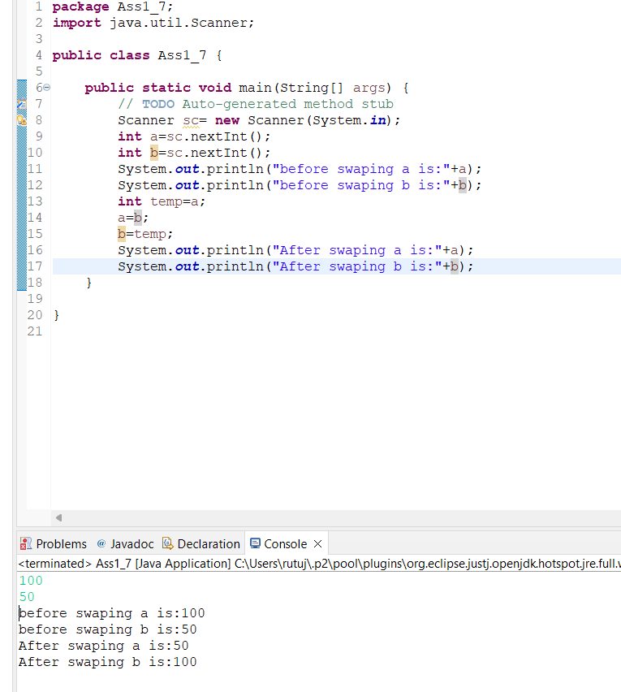

**Q7: How to swap two numbers without using a third variable?**

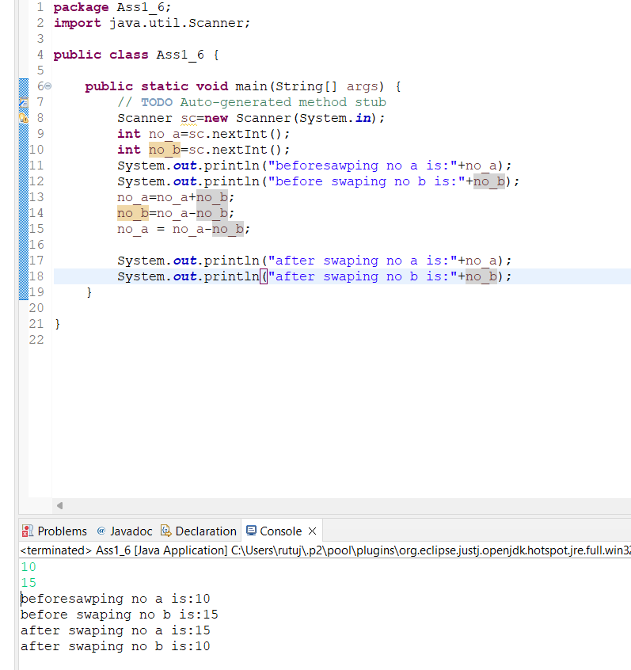

**Q8: Wap to check is number is even or odd.**

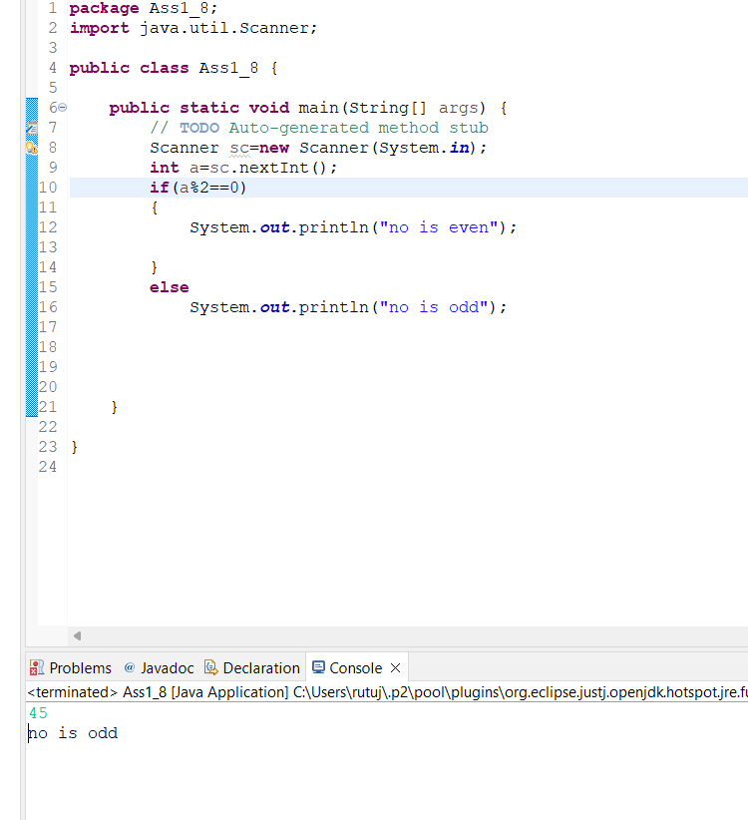

**Q9: A school has following rules for grading system:  
 a. Below 25 - F  
 b. 25 to 45 - E  
 c. 45 to 50 - D  
 d. 50 to 60 - C  
 e. 60 to 80 - B  
 f. Above 80 - A  
 Ask user to enter marks and print the corresponding grade**

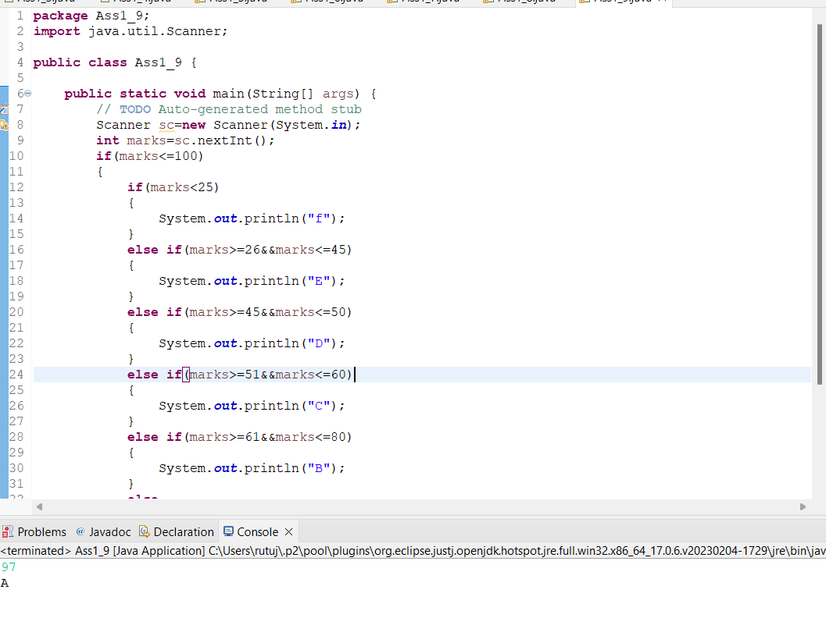

**Q10: Wap to check greater number among three numbers**

